Limitations and Drawbacks of LLM-as-a-Judge Evaluation Methods

Executive Summary
Unvalidated LLM-as-a-Judge systems are not merely ineffective—they are actively worse than having no automated evaluation at all, because they generate misleading confidence that masks real failures and distorts development decisions. Evidence from both practitioner experience and large-scale academic research converges on this conclusion: off-the-shelf LLM judges introduce systematic biases, produce illusory agreement metrics, and can be trivially fooled by adversarial inputs, all while giving teams false assurance that their AI systems are performing well.
The most critical finding is the “agreement illusion.” As Hamel Husain demonstrates, a judge that blindly predicts “Pass” on every example still achieves 95% agreement when errors occur in only 5% of cases—meaning a completely useless evaluator appears excellent by standard metrics [1]. At scale, a systematic evaluation of approximately 541,000 judgments found that chance-corrected agreement (Cohen’s κ) is 33–41 percentage points lower than raw agreement figures on MT-Bench, confirming that reported reliability is drastically overstated [2]. Compounding this, LLM judges exhibit well-quantified biases—preferring verbose responses over 90% of the time regardless of quality [3], shifting verdicts in ~34% of cases based solely on response ordering [4], and favoring their own outputs through self-enhancement bias [4]. Even frontier models like GPT-5 and Gemini-2.5-Pro fail on roughly a quarter of difficult evaluation cases [5], and adversarial exploits show that single-character inputs like “:” can fool judges into positive evaluations [4].
The actionable path forward is not to abandon LLM judges entirely but to never deploy them without first validating against domain-expert human judgments using true positive and true negative rates rather than raw agreement, reserving LLM evaluation only for genuinely subjective tasks while using deterministic code-based assertions for everything else [1]. Without this discipline, teams risk optimizing against noise—a condition demonstrably worse than operating without automated evaluation.

Introduction: The False Promise of LLM-as-a-Judge
The use of large language models as automated evaluators — commonly known as “LLM-as-a-Judge” — has become one of the most widely adopted practices in AI development. The appeal is obvious: scalable, fast, and seemingly sophisticated evaluation without the cost and latency of human review. Yet a growing body of practitioner experience and academic research reveals a troubling reality. Unvalidated LLM judges do not merely underperform — they can actively mislead development teams, creating a false sense of quality that is arguably worse than having no evaluation system at all.
This report synthesizes findings from Hamel Husain’s influential practitioner guide on building LLM judges, a comprehensive academic survey on LLM-as-a-Judge biases and limitations (arxiv 2411.15594v6), empirical benchmarking studies, and enterprise deployment guidance from AWS and DeepEval. The central argument is straightforward: without rigorous validation against human judgment, LLM-as-a-Judge systems introduce systematic biases, create illusory agreement metrics, and waste resources — all while giving teams unwarranted confidence in their AI systems.

Anti-Patterns That Make LLM Judges Counterproductive
The Four Core Mistakes. Husain identifies four recurring anti-patterns that plague teams adopting LLM judges. First, teams deploy too many metrics that become unmanageable and impossible to act upon. Second, they rely on arbitrary scoring systems using uncalibrated 1–5 scales “where the difference between scores is unclear and subjective” — nobody can reliably distinguish a 3 from a 4, and different evaluators interpret these scales differently [1, 6]. Third, teams ignore domain experts who actually understand the subject matter being evaluated. Fourth, and perhaps most damaging, they deploy unvalidated metrics that “don’t truly reflect what matters to the users or the business” [1].
The 95% Agreement Illusion. The most insidious failure mode is the deceptive nature of agreement metrics for off-the-shelf judges. Husain demonstrates this with a striking example: if errors occur in only 5% of examples, a judge that always predicts “Pass” — detecting zero actual errors — still achieves 95% agreement with ground truth [1]. This means teams can deploy a completely useless evaluator and believe it is working excellently. Off-the-shelf judges, Husain warns, “tend to cause more confusion than value” precisely because their apparent accuracy masks a total inability to detect the failures that matter [1].
Paying Frontier Prices for Regex-Solvable Checks. Enterprise deployments compound these problems with a fifth anti-pattern identified by AWS: using LLM judges for everything, including deterministic checks that a simple regular expression or code assertion could handle [7]. The cost implications are severe. Running all 13 evaluators at 100% traffic can cost approximately $800 per day — representing 80–150% of inference spend — compared to roughly $2–10 per day with a targeted 3-evaluator approach using stratified sampling [7]. DeepEval similarly notes that naive LLM-as-a-Judge implementations using a single-prompt approach with only broad criteria can be “too broad if the criteria has many hard requirements,” lacking the strict branching, hard failure gates, and inspectable decision paths needed for reliable evaluation [8].

Systematic Biases and Empirical Evidence of Failure
The academic literature has documented a taxonomy of systematic biases that fundamentally undermine LLM judge reliability. These are not edge cases — they are pervasive, well-quantified failure modes that affect every major model family.
Position Bias. LLM evaluators systematically favor responses based on their position in the prompt rather than their quality. The arxiv survey documents that Vicuna-13B could outperform ChatGPT when evaluated by ChatGPT simply by being placed in the second position. GPT-4 tends to favor the first position, while ChatGPT shows a preference for the second [4]. This means evaluation outcomes can be manipulated merely by reordering candidate responses.
Verbosity Bias. Perhaps the most damaging bias is the systematic preference for longer responses regardless of their actual quality. When answers were rephrased to be more verbose without adding any new information, judges such as Claude and GPT-3.5 still preferred the longer version more than 90% of the time [3]. This bias directly incentivizes bloated, padded outputs over concise, accurate ones — the opposite of what most applications need.
Self-Enhancement and Authority Biases. LLM evaluators exhibit a measurable preference for responses they themselves generated, a phenomenon termed self-enhancement bias [4]. Additionally, concreteness bias leads judges to favor responses containing specific details, citations, numerical values, and complex terminology — regardless of whether those details are factually correct. This effectively encourages hallucination by rewarding the appearance of authority over actual accuracy [4]. Compassion-fade bias further distorts results when model names like “gpt-4” are revealed to the evaluator, inflating scores based on reputation rather than output quality [4].
Adversarial Vulnerability. The fragility of LLM judges is perhaps best illustrated by adversarial exploits. A “null model” that outputs a constant response completely irrelevant to input instructions can achieve high win rates on automatic benchmarks. Even single-word symbols like “:” or reasoning openers like “Thought process:” can fool LLM evaluators into producing positive evaluations [4]. If a judge can be tricked by a colon, its evaluations cannot be trusted for consequential decisions.
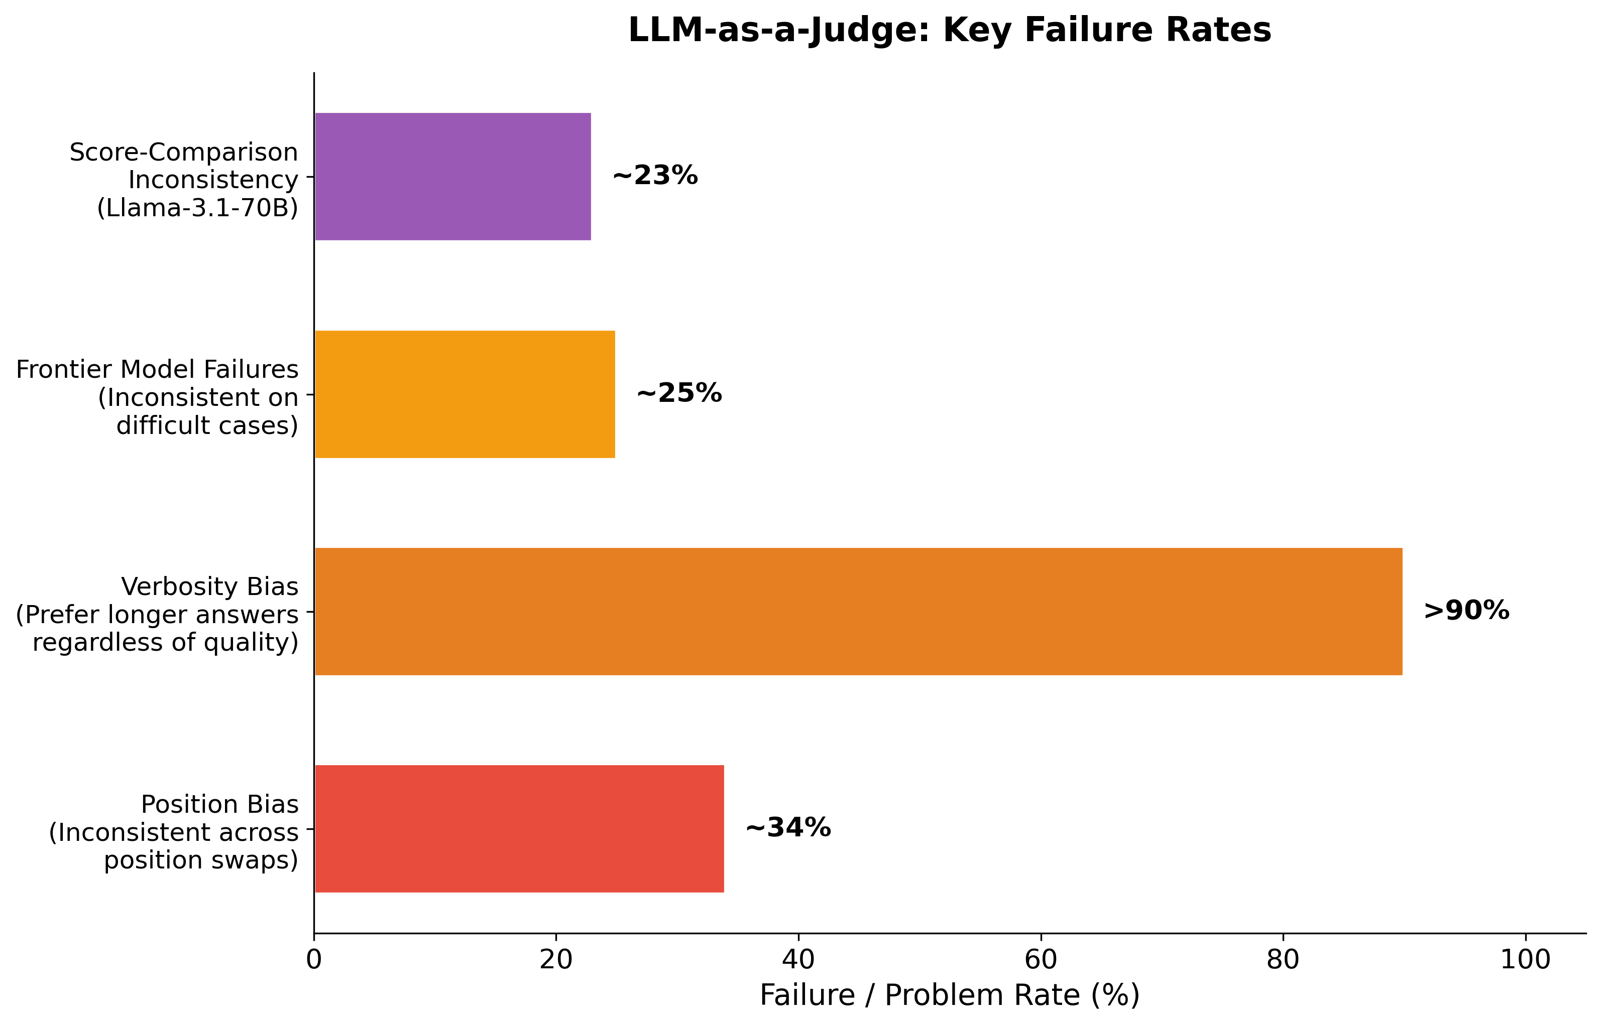
LLM-as-a-Judge Key Failure Rates
Chart Explanation: This chart quantifies the magnitude of key LLM judge failure modes. Position bias causes inconsistent verdicts in roughly 34% of cases when response order is swapped [4]. Verbosity bias leads to preference for longer answers over 90% of the time regardless of quality [3]. Frontier models like Gemini-2.5-Pro and GPT-5 fail on approximately 25% of difficult evaluation cases [5]. Score-comparison inconsistency for Llama-3.1-70B-Instruct reaches about 23% [9].

The Agreement Illusion: Overstated Reliability
Beyond individual biases, the fundamental metrics used to validate LLM judges are themselves misleading. A large-scale systematic evaluation involving approximately 541,000 judgments across 21 judges found that Cohen’s κ deflation — the gap between raw exact-match agreement and chance-corrected agreement — is 33 to 41 percentage points on MT-Bench [2]. This means that when researchers report high agreement between LLM judges and humans, they are systematically overstating the judge’s true discriminative ability by a massive margin. Judge rankings can shift by up to 14 positions across different benchmarks, further undermining claims of reliable evaluation [2].
The Consistency-Bias Paradox. One of the most counterintuitive findings is that high reliability does not imply low bias. Two production-deployed judges exhibited test-retest reliability greater than 0.95 while simultaneously showing severe position bias greater than 0.10 [2]. A judge can be perfectly consistent in its errors — reliably producing the same biased result every time — which makes the bias harder, not easier, to detect. This “consistency-bias paradox” means that standard reliability checks provide false assurance [2].
Frontier Models Are Not Immune. According to the Sage benchmark, even the top-performing models — Gemini-2.5-Pro and GPT-5 — fail to maintain consistent preferences in nearly a quarter of difficult cases [5]. Separately, Llama-3.1-70B-Instruct exhibited a 23.32% score-comparison inconsistency rate and a 15.22% pairwise transitivity inconsistency, meaning its preference orderings frequently violate basic logical consistency [9].
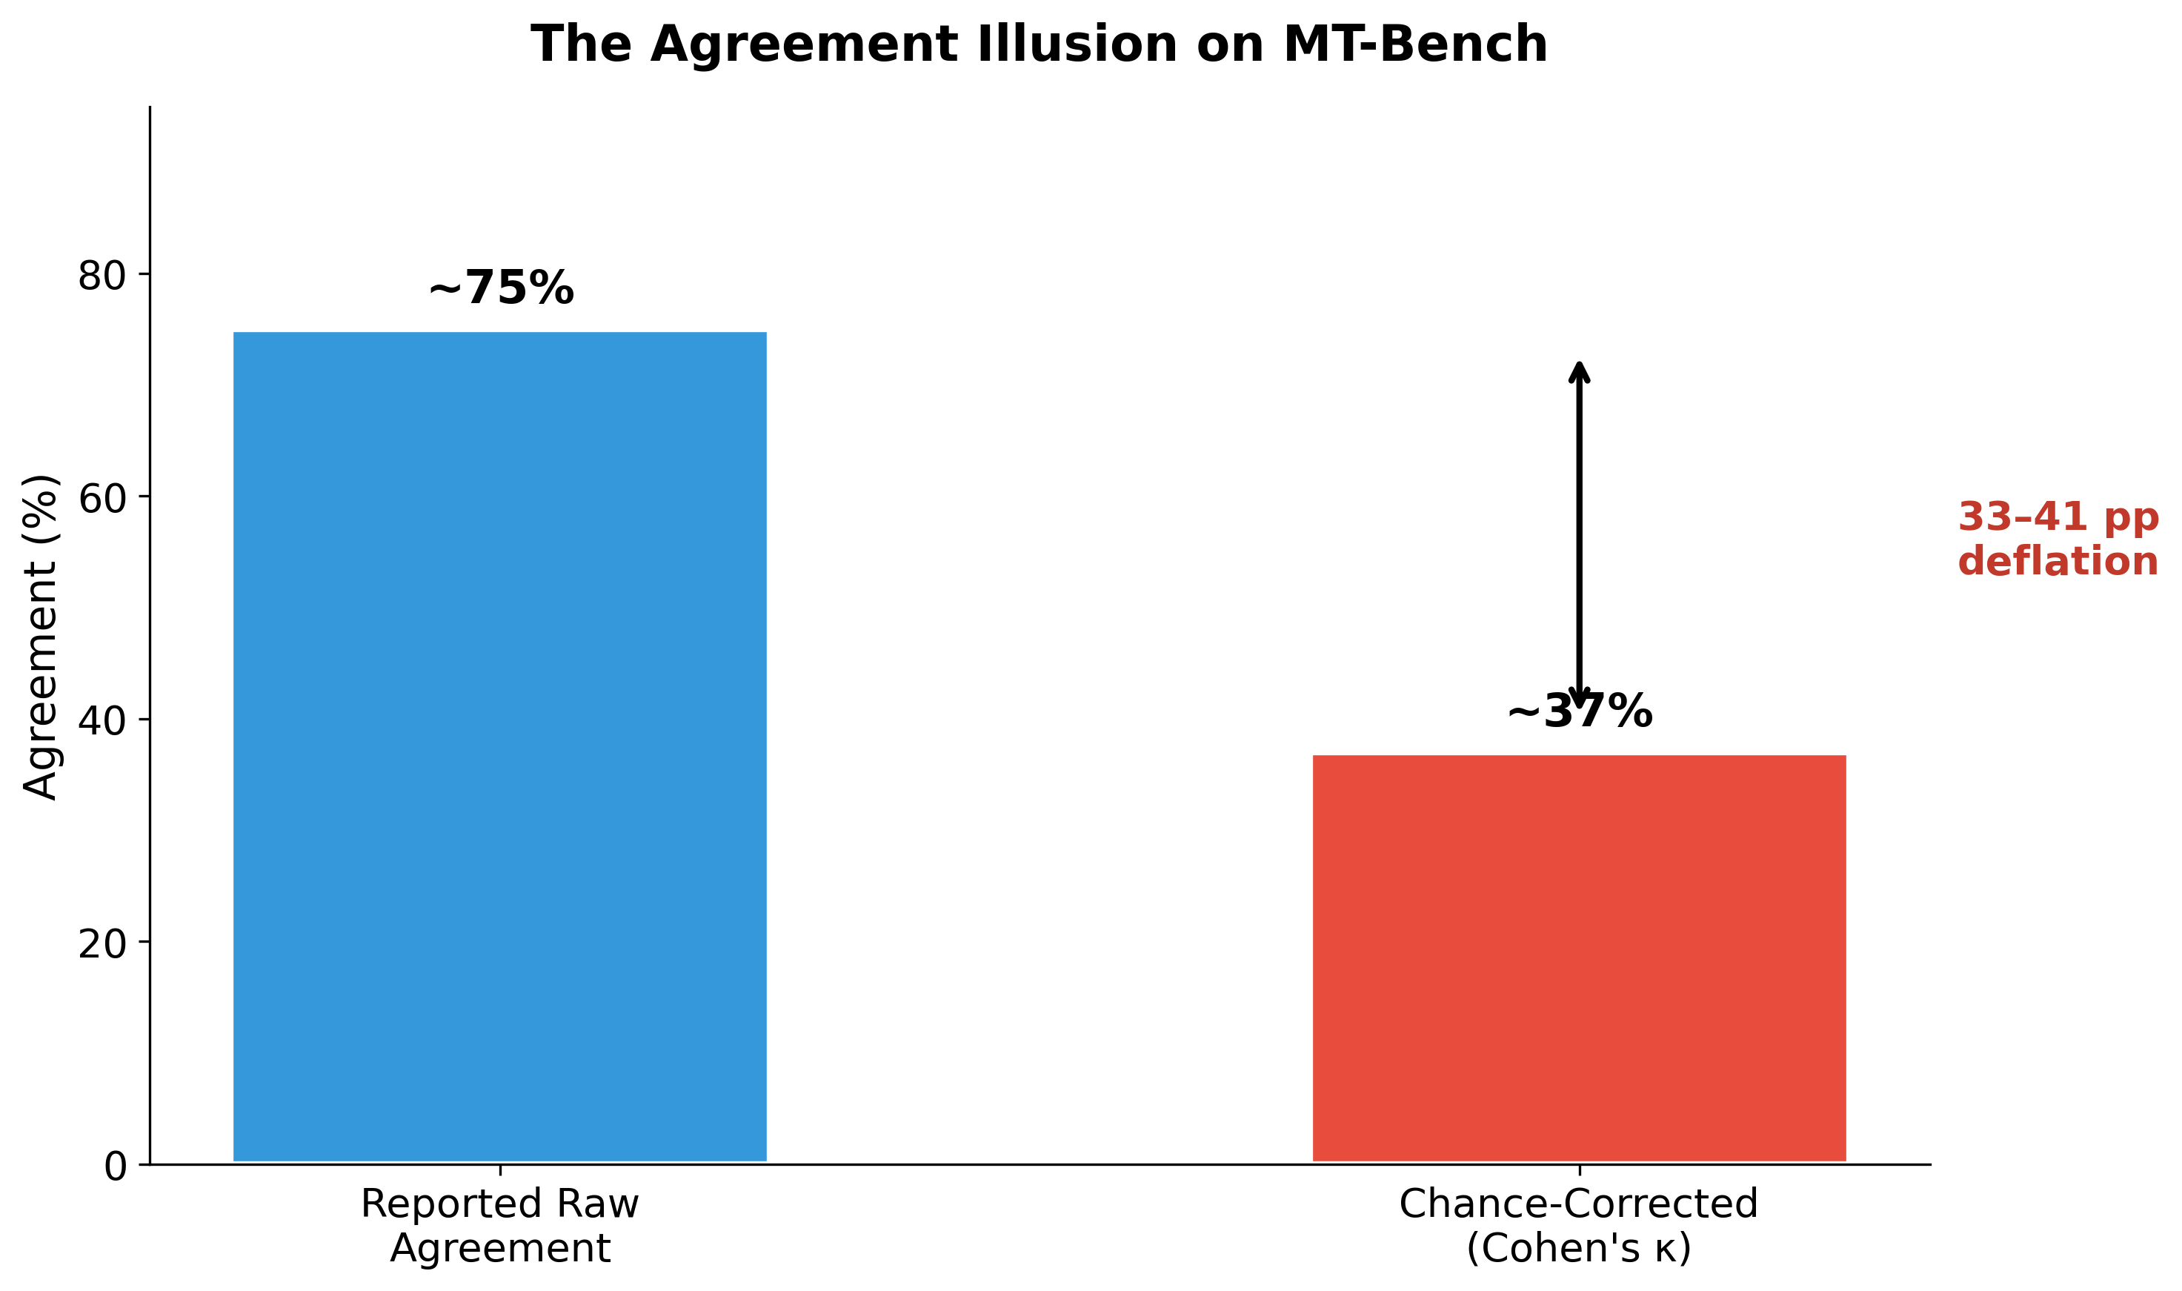
The Agreement Illusion on MT-Bench
Chart Explanation: This chart illustrates the gap between reported raw agreement and chance-corrected agreement (Cohen’s κ) on MT-Bench. The 33–41 percentage point deflation demonstrates that reported agreement figures systematically overstate the true discriminative ability of LLM judges [2].
Reproducibility Under Threat. The probabilistic nature of LLM outputs introduces fundamental reproducibility concerns. Minor changes in prompt wording or the order of examples can lead to unstable and inconsistent results [4]. The black-box nature and version dependency of commercial models like GPT-4 further hinder reproducibility — a judge validated on one model version may behave entirely differently after a silent update [4]. LLM judges also systematically miss cross-turn state issues in production agents, such as cart hallucination and escalation lockout, while catching only turn-local errors like fabricated statistics [10]. For tasks requiring specialized knowledge, the validity of using LLMs as judges remains uncertain [11].

Cost-Benefit Analysis: When Mitigation Negates the Advantage
The standard response to LLM judge biases is to apply mitigation techniques: position-swapping, multi-trial aggregation, panel-of-judges approaches, and detailed rubric engineering. However, each of these multiplies token consumption and latency, potentially negating the cost advantage over human evaluation for smaller-scale assessments. DeepEval acknowledges this tradeoff directly: “Human review is best for nuanced judgement and final QA but is slow, expensive, and inconsistent at scale. LLM-as-a-Judge is best for semantic, criteria-based LLM evaluation but needs clear criteria and reliable judge setup” to avoid misleading results [8].
The following table summarizes the cost-benefit tradeoffs across evaluation approaches:
Evaluation Approach | Strengths | Key Weaknesses | Approximate Cost
Naive LLM Judge (all traffic) | Scalable, fast | Biased, misleading agreement, adversarially vulnerable | ~$800/day for full suite [7]
Targeted LLM Judge (sampled) | Cost-efficient, focused | Still requires validation; misses cross-turn issues [10] | ~$2–10/day [7]
Code-Based Assertions | Deterministic, zero LLM cost | Cannot assess subjective quality | Minimal compute cost
Human Review | Nuanced, high validity | Slow, expensive, doesn’t scale [8] | High per-judgment cost
Hybrid (Human + LLM + Code) | Covers all failure modes | Complex to set up and maintain | Moderate
Table: Cost-Benefit Comparison of Evaluation Approaches

Recommendations: When and How to Use LLM Judges Responsibly
The evidence does not suggest that LLM judges should never be used — rather, that they must be deployed with discipline, validation, and appropriate scope. The following principles emerge from the combined practitioner and academic literature.
Validate Before You Automate. Husain’s central recommendation is a process he calls “critique shadowing”: a principal domain expert first produces pass/fail judgments with detailed written critiques, and then an LLM judge is built and calibrated against those human labels [1]. Performance must be measured using true positive and true negative rates rather than raw agreement, since agreement can be deeply misleading when failures are rare [1]. Teams should not deploy specialized LLM judges until they have completed this validation process [1, 6].
Use Code-Based Assertions First. Many evaluation checks do not require an LLM at all. Husain emphasizes that teams should use code-based assertions for errors that can be detected programmatically, reserving LLM judges only for genuinely subjective or semantic tasks [1]. AWS reinforces this with a hybrid evaluator strategy: LLM judges for subjective dimensions like helpfulness and coherence, heuristic or programmatic evaluators for deterministic checks like tool trajectory matching, and code-based Lambda evaluators for custom logic without LLM overhead [7].
Adopt Structured Evaluation Techniques. When LLM judges are appropriate, naive single-prompt approaches should be replaced with structured alternatives. DeepEval recommends G-Eval with explicit evaluation steps to reduce ambiguity, DAGMetric to break evaluation into decision trees with hard gates and deterministic scoring branches, and QAG-style metrics that decompose broad judgments into smaller closed-ended questions [8]. When false positive or false negative rates are too high, teams should tighten criteria, add strict mode, or switch to more deterministic evaluation structures [8].
Embrace Hybrid Human-AI Frameworks for High Stakes. The arxiv survey concludes that no single mitigation technique removes bias entirely, and recommends hybrid human–AI frameworks for high-stakes domains such as finance, law, and education [4]. Automatic evaluation should be treated as a validation tool rather than a definitive measure [4]. AWS operational best practices further recommend mapping the agent conversation flow first, then selecting 3–5 evaluators covering distinct failure modes, integrating evaluation as a CI/CD gate with floor scores, and ensuring every metric has an owner and a runbook before going live [7].

Conclusion
The evidence is clear: an unvalidated LLM-as-a-Judge system is not merely suboptimal — it is actively counterproductive. It creates illusory agreement metrics that mask real failures, introduces systematic biases that reward verbosity and penalize quality, and can be trivially exploited by adversarial inputs. Teams that deploy off-the-shelf judges without rigorous human-grounded validation risk making development decisions based on fundamentally misleading signals.
Husain captures the essential insight with characteristic directness: “Creating a LLM judge is a nice hack I use to trick people into carefully looking at their data” [1]. The real business value of evaluation comes not from automated scores but from the disciplined process of examining outputs, understanding failure modes, and building evaluation systems that genuinely reflect what matters. LLM judges can play a role in that process — but only when they are validated, targeted, and embedded within hybrid frameworks that combine human expertise, code-based assertions, and structured evaluation techniques. Anything less is worse than no evaluation at all.

References
1. https://hamel.dev/blog/posts/llm-judge/index.html
2. https://arxiv.org/html/2606.19544v1
3. Source: wikipedia.org
4. https://arxiv.org/html/2411.15594v6
5. https://arxiv.org/html/2512.16041v1
6. https://hamel.dev/blog/posts/llm-judge/
7. Agent_Evals.pdf
8. https://deepeval.com/blog/llm-as-a-judge
9. https://arxiv.org/html/2509.21117
10. https://arxiv.org/html/2606.10315v1
11. https://arxiv.org/html/2410.20266v1

